Уровень переноса в ABAP инструментальных средствах

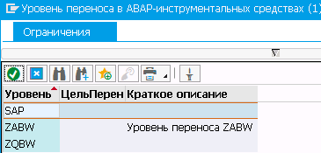

Тип пакета

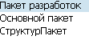

- Стандартный пакет (может содержать объекты репозитария и другие пакеты).
- Основной пакет (может содержать только другие пакеты).
- Пакет структур (может содержать только основные пакеты).

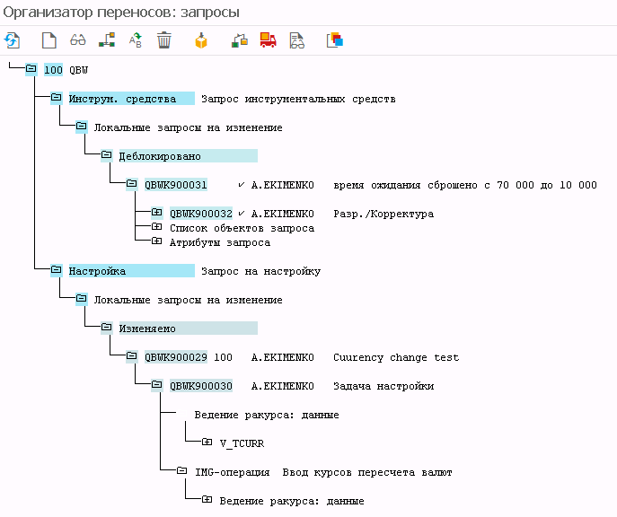

Add process chain to transport request

Способ 1
- Enter RSA1 -> Transport connections -> Under Grouping options select Only necessary objects –

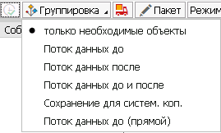

Collection mode = Manual collection -

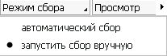

- Expand the process chain node left hand side –

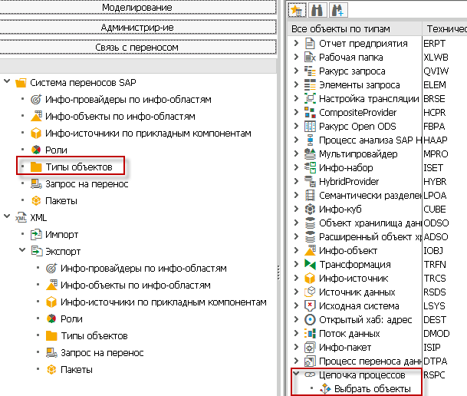

- Double click on the select objects
Pop will come -> Give there your PC technical name-> find-> enter
select the transfer selection.
then click on transport symbol-> it will generate the new TR.
select the package then will ask package for request
first transport dependent process chain then after do all.

native HANA транспорт

Transporting ABAP for SAP HANA content with HANA content with HANA Transport Container

What is HANA Transport Container?
A HANA transport container is an ABAP development object which is used to transport SAP HANA content which is used by ABAP applications (ABAP for SAP HANA). It is used for integration of HANA Repository object into the Change Transport System (CTS).

Key Features of HANA Transport Container
- Transported with standard ABAP transports
- Integrated into existing CTS transport landscape
- Integrated into SAP process tools (QGM, ChaRM)

Development Environment in HANA Transport Container

ABAP Development
- All the ABAP development is done in an ABAP development tool known as ADT (ABAP Development tool).
- Consumption of SAP HANA repository objects with the help of proxies in ABAP repository.
- Software logistic is driven by ABAP

SAP HANA Development
- SAP HANA content development is done in SAP HANA Studio.
- The HANA content is exclusively used by SAP ABAP.

Working of HANA Transport Container
- ABAP development objects integrate the SAP HANA repository object into a standard ABAP transport request with a logical transport object.
- Delivery Units is a transportable unit in SAP HANA. HANA Transport Container can be assigned to only one SAP HANA delivery unit.
- SAP HANA Objects must be transported together with ABAP development objects.

Basic SAP HANA Container Transport LandScape

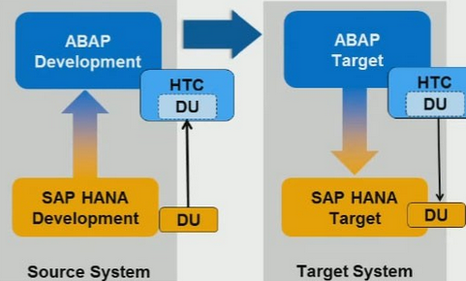

Source System
- SAP HANA studio create delivery unit and assign the relevant packages.
- In ABAP development tool an ABAP package is created and is assigned to ABAP transport request.
- HANA Transport container which comprise of 1:1 ratio assign the Delivery Unit and select and release the appropriate ABAP transport request to SAP HANA target system.
Target System
- ABAP transport request is imported
- Deploy and activation of SAP HANA content Delivery Unit with assigned packages so that we have the required object available in the target system.

Use case of HANA Transport container
- Development scenarios with SAP HANA content exclusively used by ABAP application.

Advantages of HANA Transport container
- SAP HANA artefacts are integrated into standard ABAP transport requests.
- Integration in SAP process tools (ChaRM, QGM)

Disadvantage of HANA Transport container
- SAP HANA content is part of an ABAP software component
- Software logistics for AS ABAP SAP HANA Transport Container

De’livery (dɪ'lɪv(ə)rɪ поставка) unit

Delivery unit (DU) is a container used by the Life Cycle Manager (LCM) to transport repository objects between the SAP HANA systems. The name of Delivery Unit must contain only capital letters (A-Z), digits (0-9) and underscores (_).

Creating a Delivery unit in SAP HANA using HANA Studio
Navigate to SAP HANA Modeler Perspective -> Delivery Units. In next window, click on Create button and this will open below window where you have to provide details about DU.

Delivery Unit in SAP HANA

Introduction

In SAP HANA we create all the artifacts inside some Packages. An application may include one or more packages. When we need to transport the application for one HANA system to another, all the packages should be moved together.
A delivery unit (DU) is a collection of packages that are to be transported together. We assign all the packages belonging to an application to the same DU to ensure that they are transported consistently together within different system landscape.
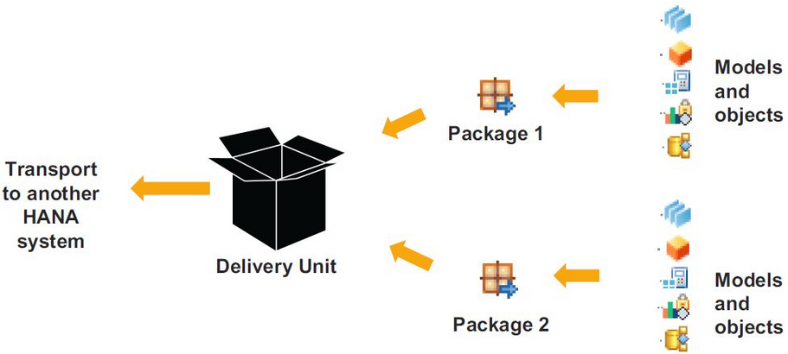

Create and Maintain Delivery Unit

Now we will see how to create and maintain delivery units in HANA.

Prerequisites
To maintain delivery units with the SAP HANA Application Lifecycle Management, you must ensure the following prerequisites are met -
- You have access to an SAP HANA system.
- You have been granted the SAP HANA sap.hana.xs.lm.roles::Administrator user role.

The steps to create and maintain Delivery Unit are -

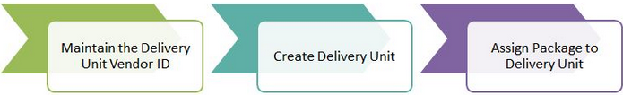

Step #1 - Maintain the Delivery-Unit Vendor ID

In SAP HANA, the vendor ID is used primarily to define the identity of the company developing a software component that it plans to ship for use with SAP HANA, for example, “sap.com”.
To create a delivery unit, it is a prerequisite to maintain a vendor ID in your system.

Steps to maintain Vendor ID -
1. Start the SAP HANA Application Lifecycle Management.
The SAP HANA Application Lifecycle Management is available on the SAP HANA XS Web server at the following URL -
http://<WebServerHost>:80<SAPHANAinstance>/sap/hana/xs/lm

2. Select “Administration” tab and click on “Change Vendor”.

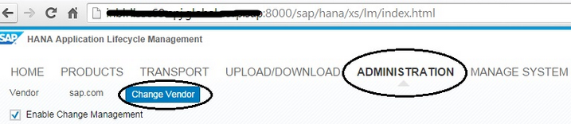

3. Enter the name of the new vendor, for example, myCompany.com. and click on “Ok”.
Note - It is highly recommended to use reserved DNS names as vendor. For example, SAP content development systems should use the vendor sap.com

You can also change the Vendor ID from HANA Studio. The steps are -
- Double click on HANA system in HANA studio.
- Go to “Configuration” tab. Type “vendor” in the filter. You will see a record “content_vendor” as below -

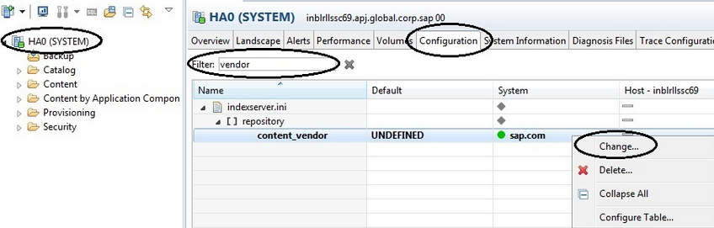

3. Right click and click on Change. Enter new vendor id and click on OK.

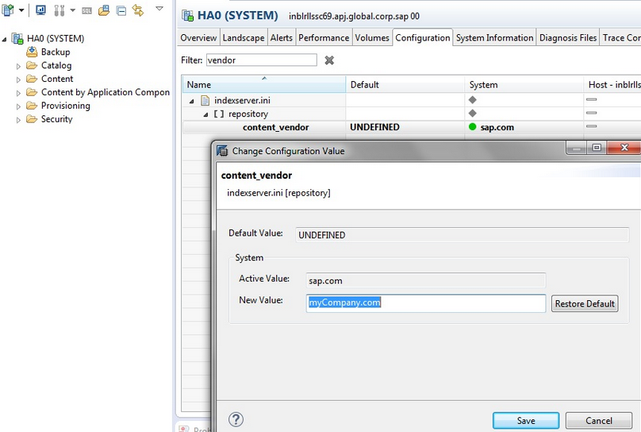

4. In case you do not see “content_vendor”, right click on repository and use “add parameter” to and add “content_vendor” manually.

Step #2 - Create a Delivery Unit

Delivery Unit can be created either by using SAP HANA Application Lifecycle Management or by using HANA Studio.

Create Delivery Unit by using SAP HANA Application Lifecycle Management -
1. Open the SAP HANA Application Lifecycle Management.
The SAP HANA Application Lifecycle Management is available on the SAP HANA XS Web server at the following URL -http://<WebServerHost>:80<SAPHANAinstance>/sap/hana/xs/lm
2. Choose the PRODUCTS tab.
3. Choose the Delivery Units tab.
4. Choose Create.

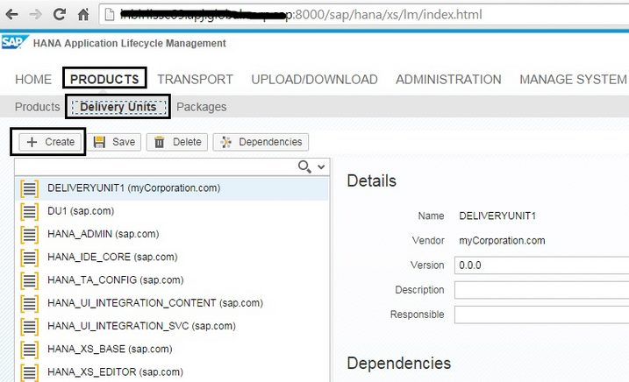

5. The New Delivery Unit dialog box appears. Enter details for the new DU.
Name - the field is mandatory and you must follow strict naming conventions, for example, use capital letters.
Vendor - this field is mandatory. However, you cannot enter a vendor here; the box is populated by the value you enter when defining the vendor in the SETTINGS tab.
Version - version numbers must take the form “#.#.#”, for example, 1.0.5, where -
- 1 = the DU version number
- 0 = the support package version (if required)
- 5 = the patch version (if required)
Note - The numbers you enter here refer to the application component that you are developing; the numbers do not refer to the patch or service-pack level deployed on the SAP HANA server.

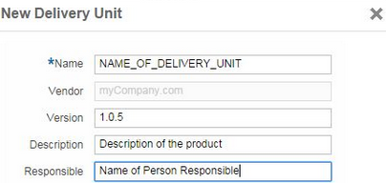

6. Choose Create.

Create Delivery Unit by using SAP HANA Studio -
1. Open HANA Studio. Go to Help àQuick Launch.
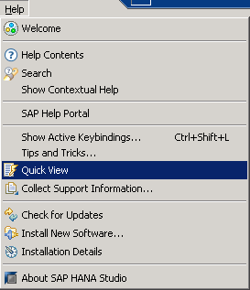
2. Click on “Delivery Unit”

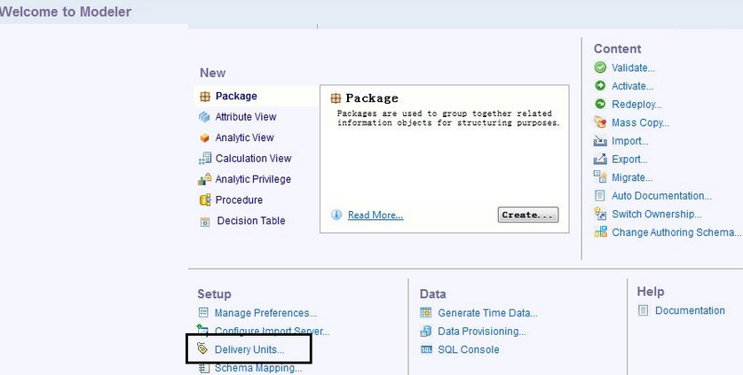

3. Click on “Create”. Provide Delivery Unit information and click on Ok.
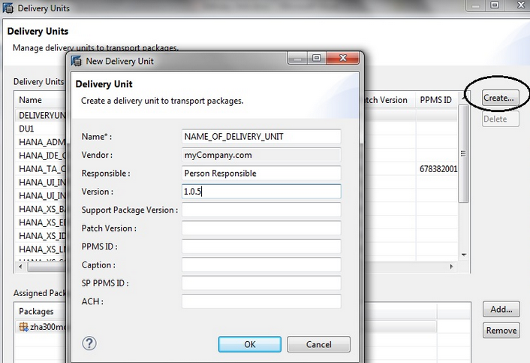

Сейчас –
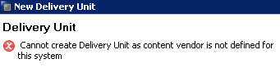

Step #3 - Assign Packages to a Delivery Unit
By default, a new delivery unit (DU) is empty; you must assign packages to it manually. To assign packages to a DU, perform the following steps -
- Open the SAP HANA Application Lifecycle Management.
- Choose the PRODUCTS tab.
- Choose the Delivery Units tab.
- Select the DU to which you want to assign some packages. The “Assigned Packages” panel displays the current contents of the selected DU -

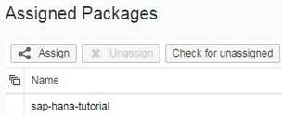

5. Assign new packages to the DU. Choose Assign and select the name of the package you want to assign to the DU.
6. Choose Check for Unassigne” to ensure that you have selected all packages and sub-packages that you want to assign to the DU. If you have missed a sub-package, select it from this dialog box and choose Assign.

We can also assign packages to Delivery Unit using HANA Studio. The steps are -
1. Open HANA Studio. Go to Help àQuick Launch.
2. Click on Delivery Unit
3. Select your Delivery Unit and click on Add. Select package and click on Ok.

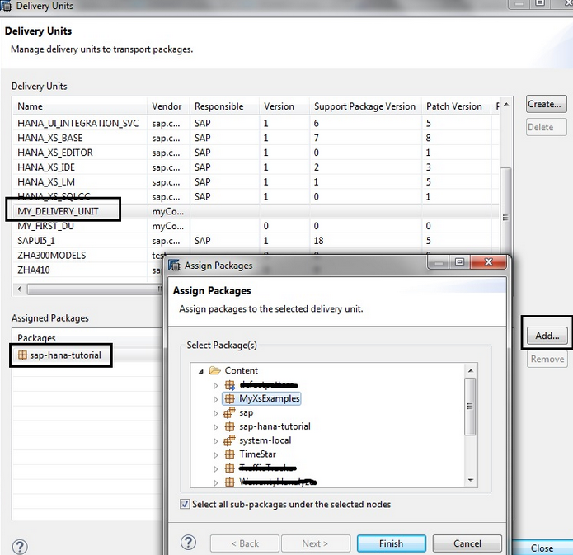

Import & Export using Delivery Unit

We can use Delivery Unit to transport content from one HANA system to other. The process is –

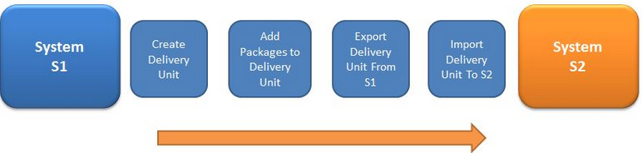

Export a Delivery Unit

You can export a delivery unit (DU), for example, to a file, for your application content or your software components using the SAP HANA Application Lifecycle Management.

Prerequisites
To export a delivery unit with the SAP HANA Application Lifecycle Management, you must ensure the following prerequisites are met -
- You have access to an SAP HANA system
- You have been granted one of the following SAP HANA user roles -
  - sap.hana.xs.lm.roles::Administrator
  - sap.hana.xs.lm.roles::ExecuteTransport

To export a DU using the SAP HANA Application Lifecycle Management, perform the following steps -
    - Open the SAP HANA Application Lifecycle Management.
- Choose the UPLOAD/DOWNLOAD tab.
- Choose the EXPORT tab.
- Select the DU you want to export.
In the Delivery Units list, locate and select the DU you want to export to a file. The Delivery Unit Import screen appears containing the list of objects included in that DU.
- Export the selected DU.
Choose Export Delivery Unit to File to display a dialog that enables you to specify the location, for example, on a local file system, where you want to save the exported DU.

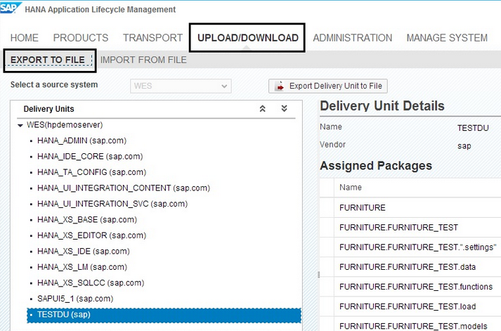

Import a Delivery Unit

You can import a delivery unit (DU), for example, from a file, for your application content or your software components using the SAP HANA Application Lifecycle Management.

Prerequisites
To import a delivery unit with the SAP HANA Application Lifecycle Management, you must ensure the following prerequisites are met -
- You have access to an SAP HANA system
- You have been granted the SAP HANA sap.hana.xs.lm.roles::Administrator user role.
- The package name of the DU does not exist in the system.

Note - Package names are case-insensitive. If you have a package name with only upper- and lower-case differences, the import fails. Delete the package from the system and then import the DU.
To import a delivery unit perform the following steps -
    - Open the SAP HANA Application Lifecycle Management.
    - Choose the UPLOAD/DOWNLOAD tab.
    - Choose the IMPORT tab.
    - Select the DU you want to import.
Choose Browse to display a file explorer, which you can use to locate the DU you want to import, and choose Open.
Note - Exported DUs have the file extension .tgz, for example, MyDU.tgz.
- The Delivery Unit Import screen appears containing the list of objects included in that DU.
- Confirm that this is the DU that you want to import.
Choose Import Delivery Unit from File to import the selected delivery unit.
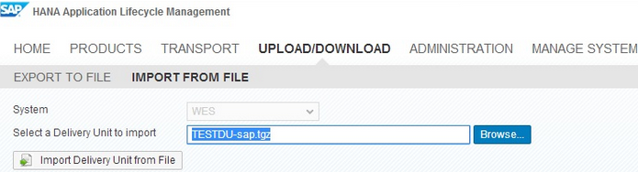

Note - The import operation overwrites any identical objects in the target system with the content of the imported DU.

create delivery unit in SAP HANA studio

HALM Usage and Troubleshooting

HALM - HANA Application Lifecycle Management.

What is HALM?
HALM stands for HANA Application Lifecycle Management, this image from the documentation explains the product lifecycle using HALM –

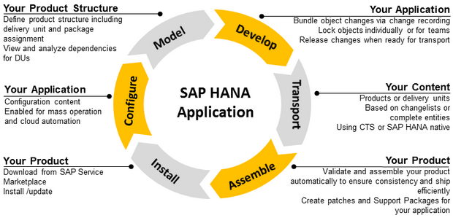

For information on this please refer to the following -
https://help.sap.com/saphelp_hanaplatform/helpdata/en/9a/012d6438764459a581e6af55a87c46/content.htm

Transport of HANA objects with HALM

I hope you already heard about HALM XS application. The HALM stands for HANA Application Lifecycle Management and the application comes with any HANA installation starting since SP6 (auto-content HANA_XS_LM DU). In short, the tool helps you to develop and transport HANA applications. You can manage products, delivery units and packages, but in this blog I would like to describe only transport capabilities and details provided by HALM. Main key transport features were already available in the first version of HALM released with HANA SP6. The HALM SP7 was already able to transport also released objects and with the HALP SP8 you can transport your changes not only between two systems, but also integrate the Change and Transport System (CTS) to transport to multiple systems. Main focus in this blog is transport of HANA repository objects with native HALM. The HALM can be accessible as http(s)://<host:port>/sap/hana/xs/lm

Add CalcULATION VIEW to transport request
http://www.saphanacentral.com/2019/01/how-to-transport-calculation-views-with.html
from Anton_Kuznetsov@atlantconsult.com
С неактивными объектами пофиксил - неактивные поломанные объекты торчали в каталоге 0CHANOTASSIGNED
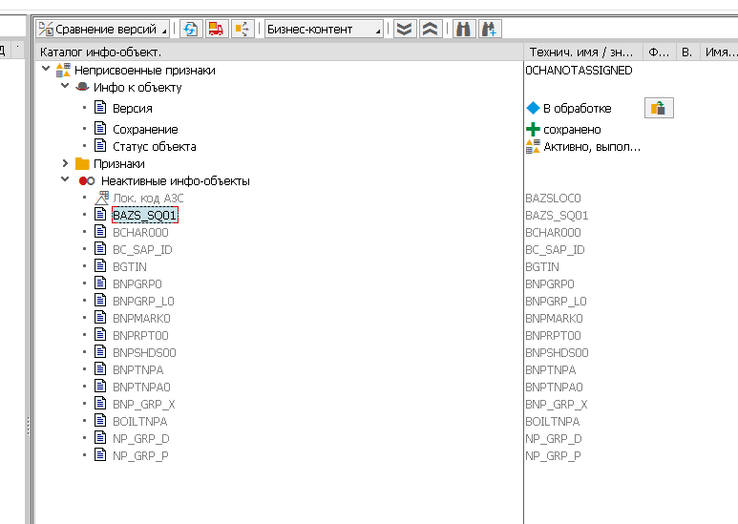
rsd1 и программа RSDG_IOBC_REPAIR помогли после нескольких итераций
можно собирать в запросы дальше

